Elevator Project

Andy Gregoire

David Parker

CS238

5/3/2011

This project simulates and tests the application of dual elevators in multiple floored buildings. It contains an explanation of how the elevator works and pictured outputs of the running program. The program was written in Assembly programming language and compiled using MASM, using the library provided by Kip Irvine.

INDEX

List of Figures ...................................................................................... Page 4

Introduction ...................................................................................... Page 5

Flowchart ...................................................................................... Page 6

Assembly Code .................................................................................. Page 7

Appendix ...................................................................................... Page 26

LIST OF FIGURES

Elevator Interface ................................................................................ Page 22

Elevator doors open ................................................................................ Page 22

Emergency Telephone ................................................................................ Page 23

Alarm Activated ................................................................................ Page 24

This program was written by Andy Gregoire and David Parker, two students enrolled in Wichita State University under the professor Amaranth Jaasti. The objective of this program is to simulate the motions of a dual elevator. Whichever elevator is closer to the destination floor should begin moving, and pick up the group of people waiting, and then take them to their destination just like a real elevator would. If either the alarm or fire buttons are pushed, both elevators will immediately move to the first floor and open their doors, letting all passengers out to safety.

Start
Elevator Called to Floor 1
Elevator 2 went to Floor 1
Elevator 1 closer than Elevator 2
Elevator 1 went to Floor 1
Elevator Called to Floor 2
Elevator 2 went to Floor 2
Elevator 1 closer than Elevator 2
Elevator 1 went to Floor 2
Elevator Called to Floor 3
Elevator 2 went to Floor
Elevator 1 closer than Elevator 3
Elevator 1 went to Floor 3
Elevator Called to Floor 4
Elevator 2 went to Floor 4
Elevator 1 closer than Elevator 2
Elevator 1 went to Floor 4
Elevator Called to Floor 5
Elevator 2 went to Floor 5
Elevator 1 closer than Elevator 2
Elevator 1 went to Floor 5
Elevator Called to Floor 6
Elevator 2 went to Floor 6
Elevator 1 closer than Elevator 2
Elevator 1 went to Floor 6
Elevator Called to Floor 7
Elevator 2 went to Floor 7
Elevator 1 closer than Elevator 2
Elevator 1 went to Floor 7
Elevator Called to Floor 8
Elevator 2 went to Floor 8
Elevator 1 closer than Elevator 8
Elevator 1 went to Floor 8
Elevator Alarm Activated
Both Elevators moved to Floor1
and Doors Stay open
Alarm Deactivated?
Elevator Fire Alarm Activated
Both Elevators moved to Floor1
and Doors Stay open
Alarm Deactivated?
Bypass Key Activated
Both Elevators moved to Floor1
and Doors Stay open
Bypass Key Deactivated?
Un -recognized Input
ASSEMBLY CODE

INCLUDE Irvine32.inc
INCLUDE Macros.inc
; ############ Both Elevators Closed Pic ############
mPic0 MACRO
call crlf
mwrite " ***** *****"
call crlf
mwrite " ***** *****"
call crlf
mwrite " ***** *****"
call crlf
mwrite " ***** *****"
call crlf
ENDM

; ############ Elevator 1 open, Elevator 2 closed pic ############
mpic1 MACRO
call crlf
mwrite " ***** *****"
call crlf
mwrite " * * *****"
call crlf
mwrite " * * *****"
call crlf
mwrite " ***** *****"
call crlf
ENDM

; ############ Elevator 1 closed, Elevator 1 Open pic ############
mPic2 MACRO
call crlf
mwrite " ***** *****"
call crlf
mwrite " ***** * *"
call crlf
mwrite " ***** * *"
call crlf
mwrite " ***** *****"
call crlf
ENDM

; ############ Both Elevators Open pic ############
mPic3 MACRO
call crlf
mwrite " ***** *****"
call crlf
mwrite " * * * *"
call crlf
mwrite " * * * *"
call crlf
mwrite " ***** *****"
call crlf
ENDM
; ############ ALARM ############
mAlarm MACRO
push eax
mtest
mpic0
mwrite " Elevator going to bottom floor"
mov eax, 4000
call Delay
call clrscr
mtest
mov eax, 07h
call writechar
mpic3
call crlf
ENDM

; ############ Door Operations for Elevator 1 ############
mDoor MACRO
push eax
mtest
mpic0
mwrite " Opening Door"
mov eax, 07h
call writechar
mov eax, 2000
call Delay
call clrscr
mtest
mpic1
mwrite " Door Open"
mov eax, 1000
call Delay
call clrscr
mtest
mpic0
mwrite " Closing Door"
mov eax, 2000
call Delay
pop eax

ENDM

; ############ kDoor Operations for Elevator 2 ############
mDoor2 MACRO
push eax
mtest
mpic0
mwrite " Opening Door"
mov eax, 07h
call writechar
mov eax, 2000
call Delay
call clrscr
mtest
mpic2
mwrite " Door Open"
mov eax, 1000
call Delay
call clrscr
mtest
mpic0
mwrite " Closing Door"
mov eax, 2000
call Delay
pop eax

ENDM

; ############ Elevator1 Motion Operation ############
mInternalDoor MACRO
call clrscr
push eax
mtest
mpic0
mwrite " Elevator in Motion"
mov eax, 4000
call Delay
call clrscr
mtest
mpic1
mwrite " Door Opening"
mov eax, 07h
call writechar
mov eax, 3000
call Delay
call clrscr
mtest
mpic0
mwrite " Door Closing"
mov eax, 4000
call Delay
pop eax
mpic0
ENDM

; ############ Elevator2 Motion Operation ############
mInternalDoor2 MACRO
call clrscr
push eax
mtest
mpic0
mwrite " Elevator in Motion"
mov eax, 4000
call Delay
call clrscr
mtest
mpic2
mwrite " Door Opening"
mov eax, 07h
call writechar
mov eax, 3000
call Delay
call clrscr
mtest
mpic0
mwrite " Door Closing"
mov eax, 4000
call Delay
pop eax
mpic0
ENDM

; ############ Internal/External Display Board Options ############
mMenu MACRO

mwrite " ~~~~ Options ~~~~"
call crlf
mwrite " 0: Down 9: Up"
call crlf
mwrite " L: Exit Elevator d: Bypass Key "
call crlf
mwrite " s: Alarm f: Fire Alarm "
call crlf
mwrite " g: Open Door h: Close Door "
call crlf
mwrite " b: Emergency Telephone "
mwrite " ~~~~Elevator 1~~~~"
call crlf
mwrite " 1: First Floor 5: Fifth Floor"
call crlf
mwrite " 2: Second Floor 6: Sixth Floor"
call crlf
mwrite " 3: Third Floor 7: Seventh Floor"

mwrite " 4: Fourth floor 8: Eighth Floor"
call crlf
mwrite " ~~~~Elevator 2~~~~"
call crlf
mwrite " q: First Floor t: Fifth Floor"
call crlf
mwrite " w: Second Floor y: Sixth Floor"
call crlf
mwrite " e: Third Floor u: Seventh Floor"
mwrite " r: Fourth floor i: Eighth Floor"
call crlf
call crlf
ENDM

; ############ Elevator Floor Log ############
mtest MACRO
mMenu
mwrite " Elevator 1: Floor "
mov eax, Elevator1
call writedec
mwrite " Elevator 2: Floor "
mov eax, Elevator2
call writedec
ENDM

.data
Elevator1 SDWORD ?
Elevator2 SDWORD ?
.code
program:

call clrscr
mov Elevator1, 1
mov Elevator2, 1

; ############ Choose which Elevator to use ############
Chfloor:
call clrscr
mtest
mpic0
call crlf
mwrite "Enter the floor level you are on (1 - 8)" ;this chooses which Elevator is closest and uses it
call crlf ;Dependent on which floor the elevators is currently on
call readchar ;this is always brought up after leaving the elevator ;'L'

cmp eax, 561
je one
cmp eax, 818
je two
cmp eax, 1075 ;Converts readchar values to decimal values
je three ;Used for permitting setting off alarms outside of elevator
cmp eax, 1332
je four
cmp eax, 1589
je five
cmp eax, 1846
je six
cmp eax, 2103
je seven
cmp eax, 2360
je eight
cmp eax, 8051
cmp eax, 8051
je Alarm ; Alarm
cmp eax, 8292
je Bypass ; Bypass Key
cmp eax, 8550
je Fire ; Fire Alarm
cmp eax, 2864
je zero
cmp eax, 2617
je nine

zero:
mov eax, 0
jmp done
one:
mov eax, 1
jmp done
two:
mov eax, 2
jmp done
three:
mov eax, 3
jmp done
four:
mov eax, 4
jmp done
five:
mov eax, 5
jmp done
six:
mov eax, 6
jmp done
seven:
mov eax, 7
jmp done
eight:
mov eax, 8
jmp done
nine:
mov eax, 9
jmp done

done:

mov ebx, eax
cmp eax, 0
je Chfloor
cmp eax, 8
jg Chfloor

Choose:
cmp Elevator1, ebx
je menu
cmp Elevator2, ebx
je menu2
cmp Elevator1, ebx
jl L1
jmp L2

L1:
mov ecx, ebx
sub ecx, Elevator1
jmp done1
L2:
mov ecx, Elevator1
sub ecx, ebx
jmp done1
done1:
cmp Elevator2, ebx
jl L3
jmp L4

L3:
mov edx, ebx
sub edx, Elevator2
jmp done2
L4:
mov edx, Elevator2
sub edx, ebx
jmp done2

done2:

cmp ecx, edx
jg Menu2 ;Elevator2 Menu
cmp ecx, edx
jle Menu ;Elevator1 Menu
jmp Choose
; ############ End - Choose which Elevator to use ############

; ############ Elevator1 Options (up, down, alarm, etc..) ############
Menu:
call clrscr
mtest
mpic0
mwrite " Enter Direction ( Up or Down)"
call crlf
call readchar
cmp eax, 2617
je Doorx
cmp eax, 2864
je Doorx
cmp eax, 8051
je Alarm ; Alarm
cmp eax, 8292
je Bypass ;Bypass Key
cmp eax, 8550
je Fire ;Fire Alarm
jmp Exits
; ############ End - Elevator1 Options (up, down, alarm, etc..) ############

; ############ Elevator2 Options (up, down, alarm, etc..) ############
Menu2:
call clrscr
mtest
mpic0
mwrite " Enter Direction ( Up or Down)"
call crlf
call readchar
cmp eax, 2617
je Doory
cmp eax, 2864
je Doory
cmp eax, 8051
je Alarm ; Alarm
cmp eax, 8292
je Bypass ; Bypass Key
cmp eax, 8550
je Fire ;Fire Alarm
jmp Exitt
; ############ End - Elevator2 Options (up, down, alarm, etc..) ############

; ############ Elevator1 Input (Inside) ############
Doorx:
mov Elevator1, ebx
mInternalDoor

Internal:
call clrscr
mtest
mpic0
mwrite "Enter Desired Floor (Elevator 1) "
call crlf
call readchar
cmp eax, 561
je floor1
cmp eax, 818
je floor2
cmp eax, 1075
je floor3
cmp eax, 1332
je floor4
cmp eax, 1589
je floor11
cmp eax, 1846
je floor12
cmp eax, 2103
je floor13
cmp eax, 2360
je floor14
cmp eax, 8051
je Alarm
cmp eax, 8292
je Bypass
cmp eax, 8550
je Fire
cmp eax, 9836
je Chfloor
cmp eax, 8807
je Open1
cmp eax, 12386
je ETelephone
jmp Internal
; ############ End - Elevator1 Input (Inside) ############

; ############ Elevator2 Input (Inside) ############

Doory:
mov Elevator2, ebx
mInternalDoor2
Internal2:
call clrscr
mtest
mpic0
mwrite "Enter Desired Floor (Elevator 2) "
call crlf
call readchar
cmp eax, 4209
je floor5
cmp eax, 4471
je floor6
cmp eax, 4709
je floor7
cmp eax, 4978
je floor8
cmp eax, 5236
je floor15
cmp eax, 5497
je floor16
cmp eax, 5749
je floor17
cmp eax, 5993
je floor18
cmp eax, 8051
je Alarm
cmp eax, 8292
je Bypass
cmp eax, 8550
je Fire
cmp eax, 9836
je Chfloor
cmp eax, 8807
je Open2
cmp eax, 12386
je ETelephone2
jmp Internal2
; ############ End - Elevator2 Input (Inside) ############

; ############ Eelvator 1 Floors ############
floor1: ;Floor1
mov Elevator1, 1
call clrscr
mtest
mpic0
mInternalDoor
call Clrscr
mtest
mPic0
jmp Internal

floor2: ;Floor2
mov Elevator1, 2
call clrscr
mMenu
mInternalDoor
call Clrscr
mtest
mPic0
jmp Internal

floor3: ;Floor3
mov Elevator1, 3
call clrscr
mMenu
mInternalDoor
call Clrscr
mtest
mPic0
jmp Internal

floor4: ;Floor4
mov Elevator1, 4
call clrscr
mtest
mInternalDoor
call Clrscr
mMenu
mPic0
jmp Internal

floor11: ;Floor5
mov Elevator1, 5
call clrscr
mtest
mpic0
mInternalDoor
call Clrscr
mtest
call writedec
mPic0
jmp Internal

floor12: ;Floor6
mov Elevator1, 6
call clrscr
mMenu
mInternalDoor
call Clrscr
mtest
mPic0
jmp Internal

floor13: ;Floor7
mov Elevator1, 7
call clrscr
mMenu
mInternalDoor
call Clrscr
mtest
mPic0
jmp Internal

floor14: ;Floor8
mov Elevator1, 8
call clrscr
mtest
mInternalDoor
call Clrscr
mMenu
mPic0
jmp Internal

Open1:
call Clrscr
mtest
mpic0
mov eax, 1000
call delay
point1:
call clrscr
mtest
mpic1
mwrite "Elevator Open: h to close elevator"
call crlf
call readchar
cmp eax, 9064
je Internal
jmp point1

ETelephone:
call Clrscr
mtest
mpic0
mwrite "What is your Emergency? "
call crlf
call readdec
call crlf
mwrite " Help is on the way! "
mov eax, 2000
call delay
jmp Internal
; ############ End - Elevator 1 Floors ############

; ############ Elevator 2 Floors ############
floor5: ; Floor 1
mov Elevator2, 1
call clrscr
mtest
mpic0
mInternalDoor2
call Clrscr
mtest
mPic0
jmp Internal2

floor6: ; Floor 2
mov Elevator2, 2
call clrscr
mMenu
mInternalDoor2
call Clrscr
mtest
mPic0
jmp Internal2

floor7: ; Floor 3
mov Elevator2, 3
call clrscr
mMenu
mInternalDoor2
call Clrscr
mtest
mPic0
jmp Internal2

floor8: ; Floor 4
mov Elevator2, 4
call clrscr
mMenu
mInternalDoor2
call Clrscr
mtest
mPic0
jmp Internal2

floor15: ; Floor 5
mov Elevator2, 5
call clrscr
mtest
mpic0
mInternalDoor2
call Clrscr
mtest
mPic0
jmp Internal2

floor16: ; Floor 6
mov Elevator2, 6
call clrscr
mMenu
mInternalDoor2
call Clrscr
mtest
mPic0
jmp Internal2

floor17: ; Floor 7
mov Elevator2, 7
call clrscr
mMenu
mInternalDoor2
call Clrscr
mtest
mPic0
jmp Internal2

floor18: ; Floor 8
mov Elevator2, 8
call clrscr
mMenu
mInternalDoor2
call Clrscr
mtest
mPic0
jmp Internal2
Open2:
call Clrscr
mtest
mpic0
mov eax, 1000
call delay
point2:
call clrscr
mtest
mpic2
mwrite "Elevator Open: h to close elevator"
call crlf
call readchar
cmp eax, 9064
je Internal2
jmp point2
ETelephone2:
call Clrscr
mtest
mpic0
mwrite "What is your Emergency? "
call crlf
call readdec
call crlf
mwrite " Help is on the way! "
mov eax, 2000
call delay
jmp Internal2
; ############ End - Elevator 2 Floors ############

Exits:
call Clrscr
jmp menu
Exitt:
call Clrscr
jmp menu2

; ############ Alarm ############
Alarm:
mov Elevator1, 1
mov Elevator2, 1
call clrscr
mAlarm

mwrite " Alarm Activated: 'S' to deactivate "
call crlf
call readchar
cmp eax, 8051
je program
jmp Alarm
; ############ End - Alarm ############

; ############ Fire ############
Fire:
mov Elevator1, 1
mov Elevator2, 1
call clrscr
mAlarm
mwrite "Fire Alarm Activated: 'f' to deactive "
call crlf
call readchar
cmp eax, 8550
je program
jmp Fire
; ############ End - Fire ############

; ############ Bypass Key ############
Bypass:
mov Elevator1, 1
mov Elevator2, 1
call clrscr
mAlarm
mwrite "Bypass Key Activated: 'd' to deactive "
call crlf
call readchar
cmp eax, 8292
je program
jmp Bypass
; ############ End - Bypass Key ############

end program

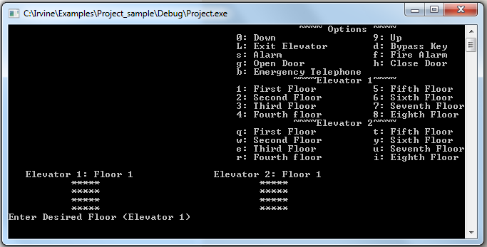

This is the basic Elevator Interface

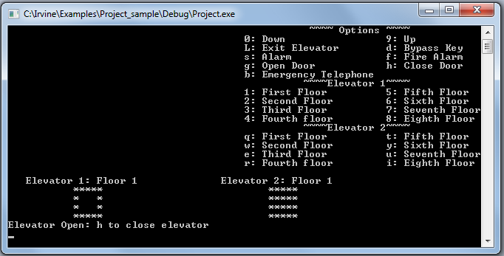

This is output picture of Elevator 1 Open

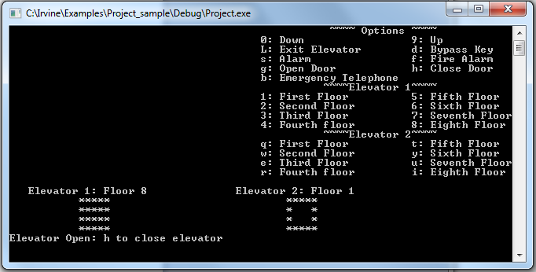

This is an output picture of Elevator 2 open

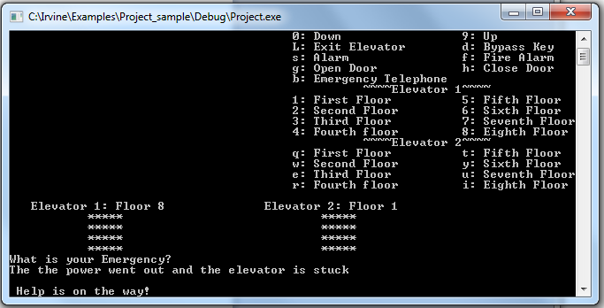

This is an output picture of using the Emergency Phone ( The string: "The Power went out and the elevator is stuck" is just an example you may use your own "Emergency")

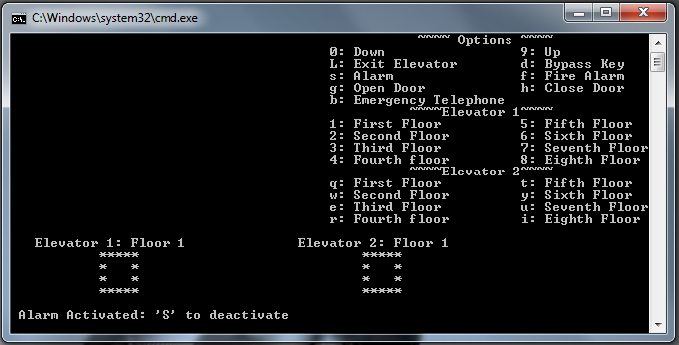

This is an output picture of the Elevator Alarm being activated. (Similar to Fire Alarm and Bypass Key)

How it Works:

- Enter the floor your currently on
- choose up or down
- Elevator picks you up & choose which floor(s) you wish to visit
- When at your destination you enter 'L' to leave the elevator ( this will tell the program your done with the current elevator, looping back to the start)

NOTES:

- Both elevators may not run at the same time, however elevator preference will be given to closest elevator to called floor
- Elevator "Dings" when it reaches its destination (have volume on)
- This program is caps sensitive (Everything is lower case, some of the interface options are in caps for readability)

Appendix

Index ...................................................................................... Page 3

List of Figures ...................................................................................... Page 4

Introduction ...................................................................................... Page 5

Flowchart ...................................................................................... Page 6

Assembly Code .................................................................................. Page 9

